**Architecture Pattern:**

Before starting any project decide the architecture pattern you will use to build that project

We have 2 categories for projects classification:

* monolithic architecture: the project is divided modules or services in the same project /or solution /or system 🡺 what we’ll cover on MVC course
* micro services: each group of services in separate project [each project may be implemented with different technology]

**3 Layers Architecture Pattern:**

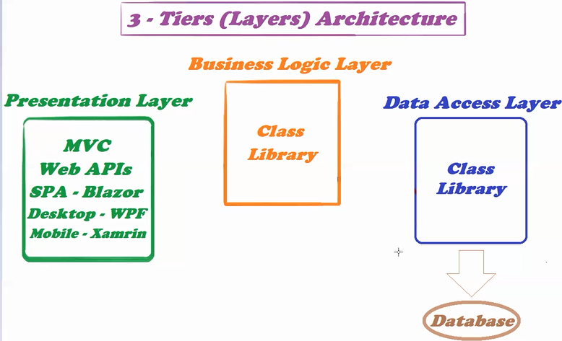

Add reference from data access layer to the business access layer and add reference from the business access layer to the presentation access layer

Each installed package in one layer is seen in the other layers

Add reference then build the solution so that the changes in packages takes place

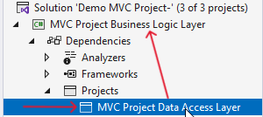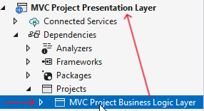

1. **Data Access Layer:**

**DbContext – Dependency Injection:**

**App Settings – Connection String:**

**Generate Migration:**

1. **Business Logic Layer**
2. **Presentation Layer – MVC Template**

**Department Controller – Dependency Injection:**

**Department Controller – Index**

**Department Controller - Create**